Normal Attack
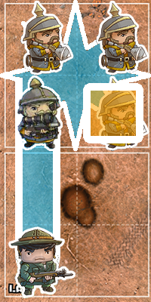 | Use the Target Order Tracker to select a Target:  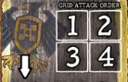  In this example the Allied Rifleman must attack the Blight Panzerfaust. The Allied Rifleman can roll 3 D6.
Flat Grid Attack
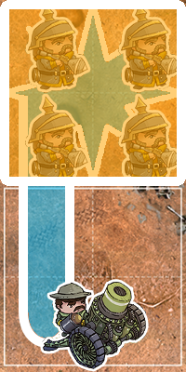 | When an attack with this ability is used, attack each unit in the targeted grid.  In this example the Allied Hammer 65 Pounder will attack each Blight Panzerfaust.  The Hammer Pounder can roll 2 D6 against each Panzerfaust.
Chain Grid Attack
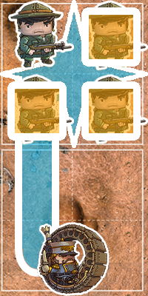 | When an attack with this ability hits a target, attack the next unit in grid attack order. Continue making attacks until you miss an attack or all units have been attacked.  The Blight Monowheel Dragoon can roll 2 D6 against the Allied Rifleman in square 1. If it hits, the Monowheel can attack the Rifleman in square 2; and so on.  If an attack is unsuccessful, no further attacks can be made.
Grid Attack Order

